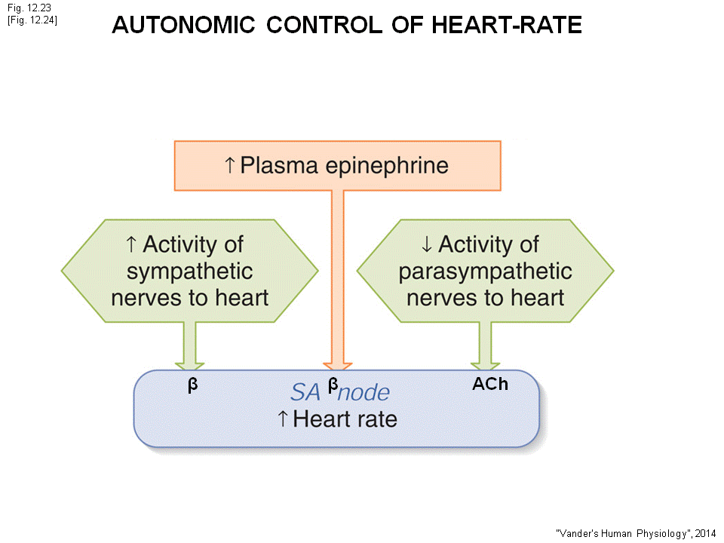
When exercise, activate the sympathetic nervous system, inactivate parasympathetic nervous system.
- The autonomic nervous system: if sympathetic goes up, parasympathetic goes down (vice versa)
- When exercise
- Increase(activate) the sympathetic nervous system will cause the NE to beta- adrenergic receptor : heart rate increase
- Activate the sympathetic, increase the plasma EP and NE, EP bind to Beta receptor on SA heart rate increase
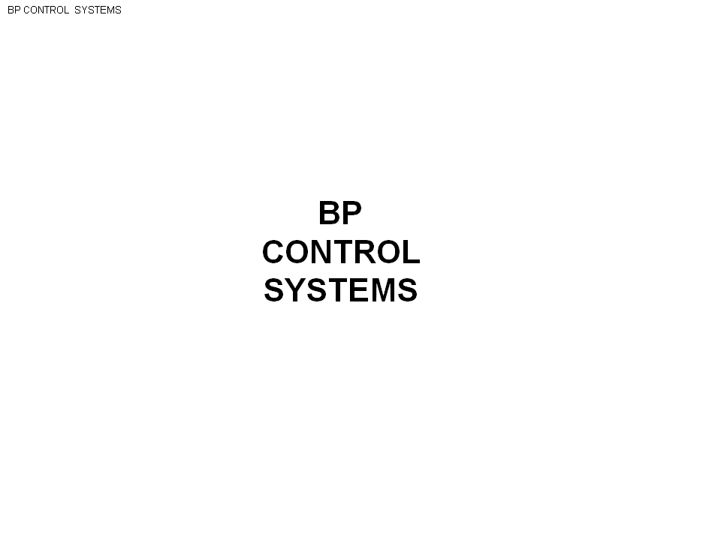
- Withdraw, decrease of parasympathetic, the heart rate goes up.

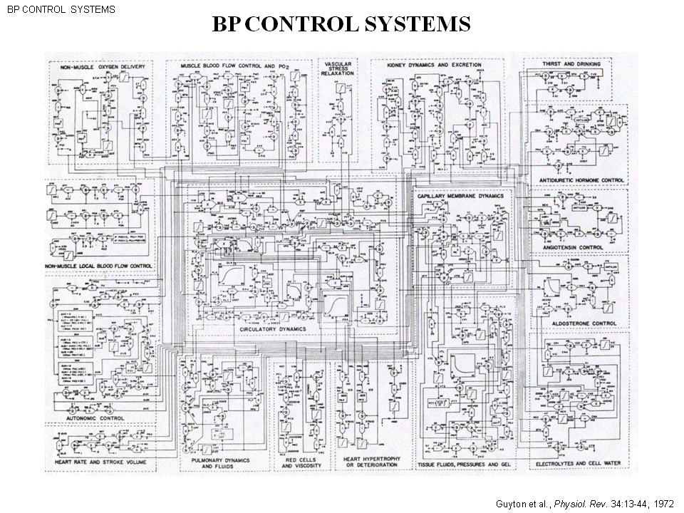

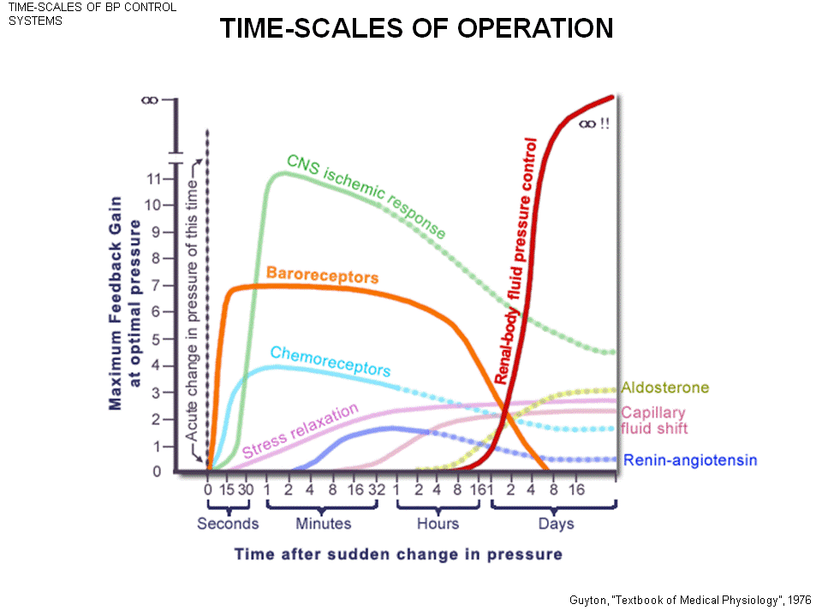
Blood pressure control system is complicated.
There is 6 different system blood pressure control
- The reason why you don’t faint when stand up : because there is a particular control in one heart beat to get the blood pressure back up.
- On the diagram you can Barorecpetor act extremely quickly (within seconds)
- The thing to keep blood pressure 100mmHG, is kidney. The kidney re absorb more or less water => control the blood volume => control the blood pressure (this is long term)
- All of these controls are in different time scale (range form one second to days) -range of operation
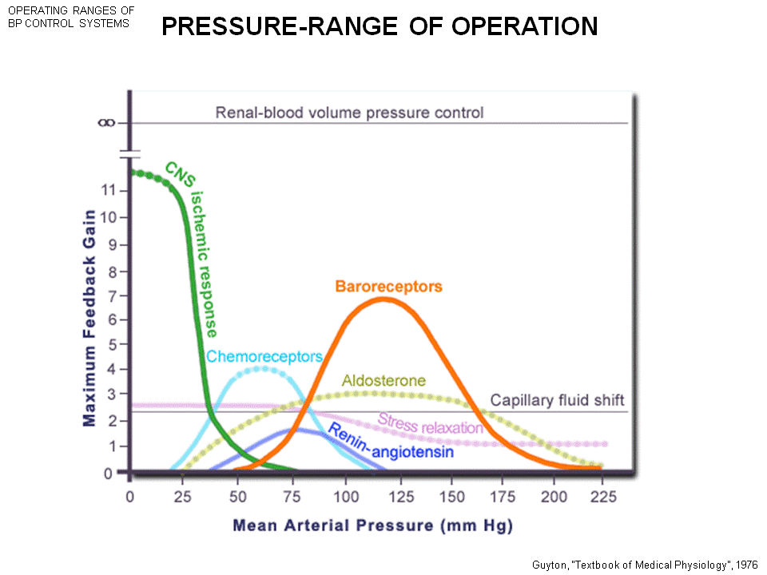
The regulation is also in different range of pressure
- Baroreceptor that stop you from fainting, regulate in a normal range
- Can ischemic only happen when in very low blood pressure
- The different system work in different speed and different ranges
- The reflection has different strength, ex: in the previous slide, renal body fluid pressure control is a powerful reflex. There is also week reflect
- So reflection can work strongly, weakly, slowly, quickly, high, low blood pressure range


The baro (pressure measure) receptor reflex

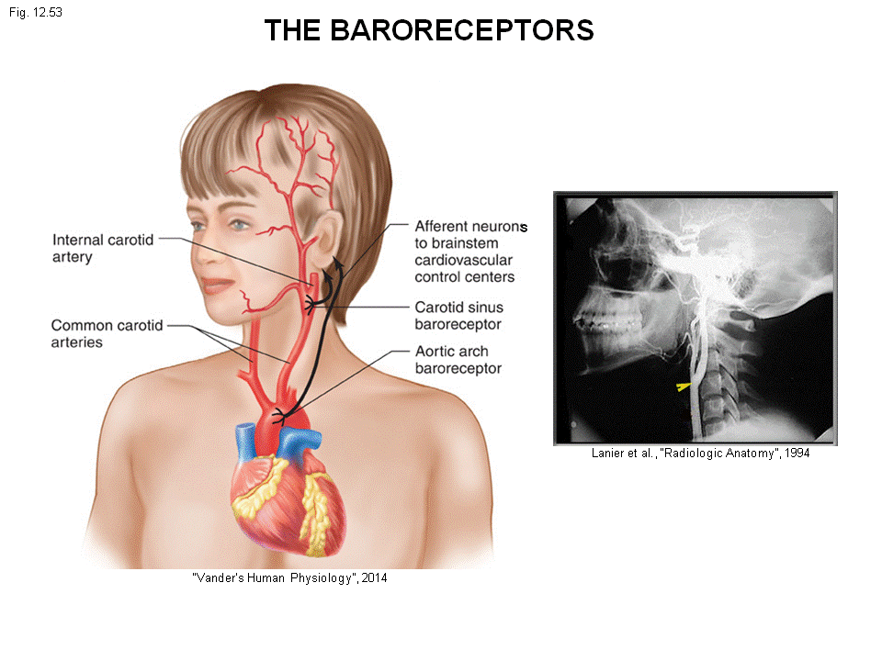

Baroreceptor
- Common artery breaks into the internal branch to brain and external to the faces, jars.
- You can find nerve terminals in there
- Same in heart, aorta. when heart beats the pulse wave stretches arteries the walls stretch nerve terminals stretch fire action potential information up to the brain
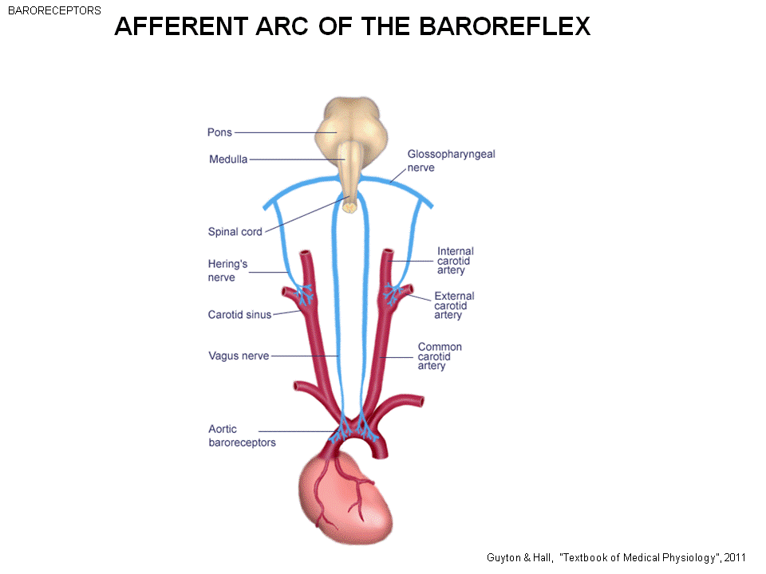
The information goes from baroreceptor nerve terminals up to the brain.
- From the baroreceptor, aortic arch, carotid sinus
- The more the receptor stretches, the more action potential send up to the brain
- Blood pressure up more stretch more action potential up to the brain
- If Bp drops fewer action potential goes up to the brain
- This is the afferent arc of the baroreflex
- Afferent (info that goes up)
- The brain tell the blood pressure change

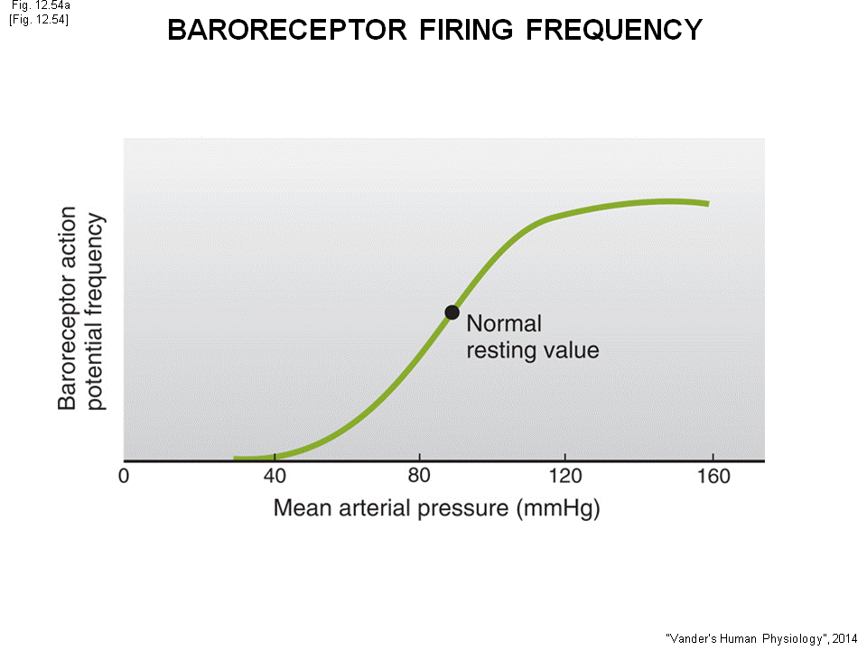
The mean arterial BP increases
- The baroreceptor frequency of firing action potential will increase
- This is the part of reflex

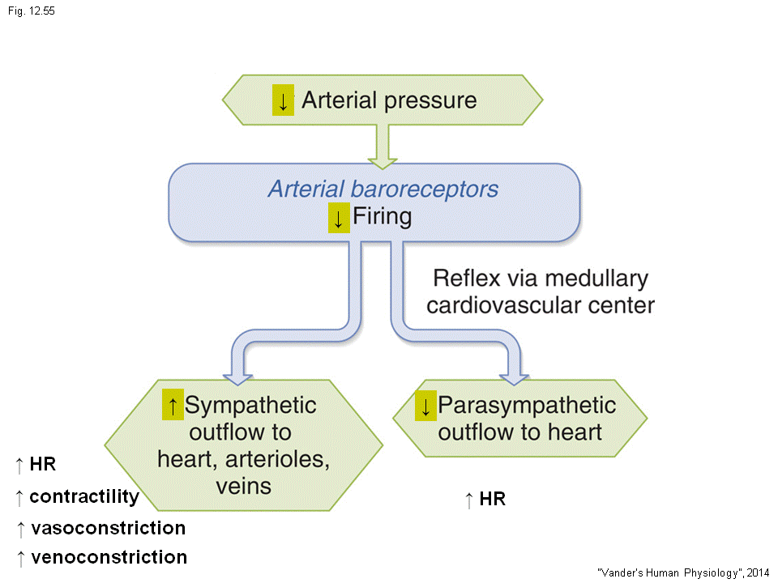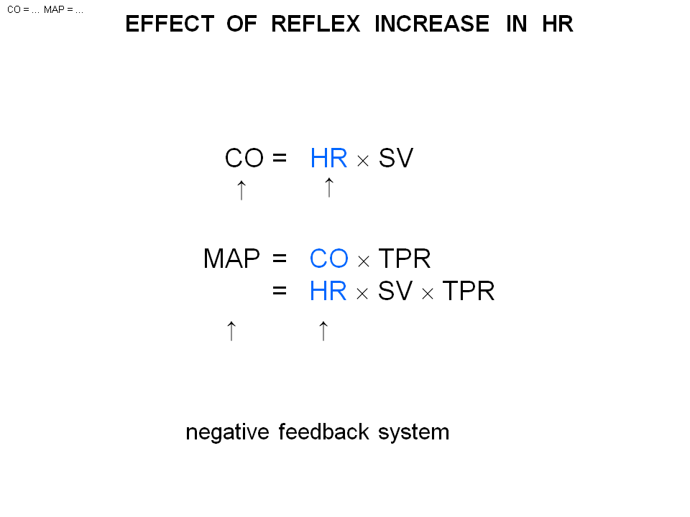
Now suppose BP drops
- Less stretch, fewer action potential to the brain
- The brain tell the Bp has drop do something to the nervous system
- Activate SYMPATHETIC nervous system, decrease the PARASYMPATHETIC
- This is what baroreceptor does
So 4 things happen
- Increase the heart rate
Sympathetic system activated influence heart rate and contractility
- Increase HR Cardiac output goes up BP goes up
- Restore the BP back to normal
- Negative feedback ( fall in BP, BP goes up)
- If the BP rise, everything in opposite direction. The blood pressure goes back down

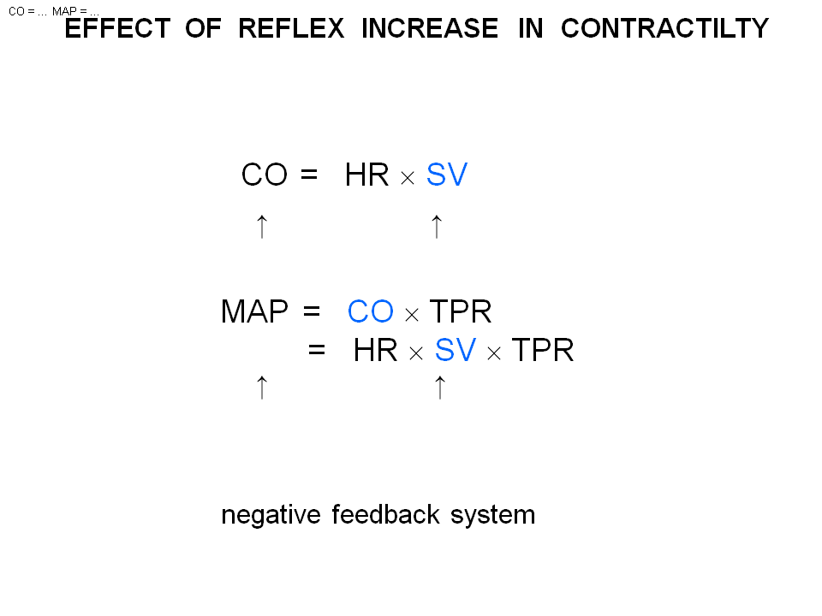
- Increase the contractility (increase contraction)
- Stroke volume increase
- CO goes up mean arterial blood pressure goes up
- Same the negative feedback reflex

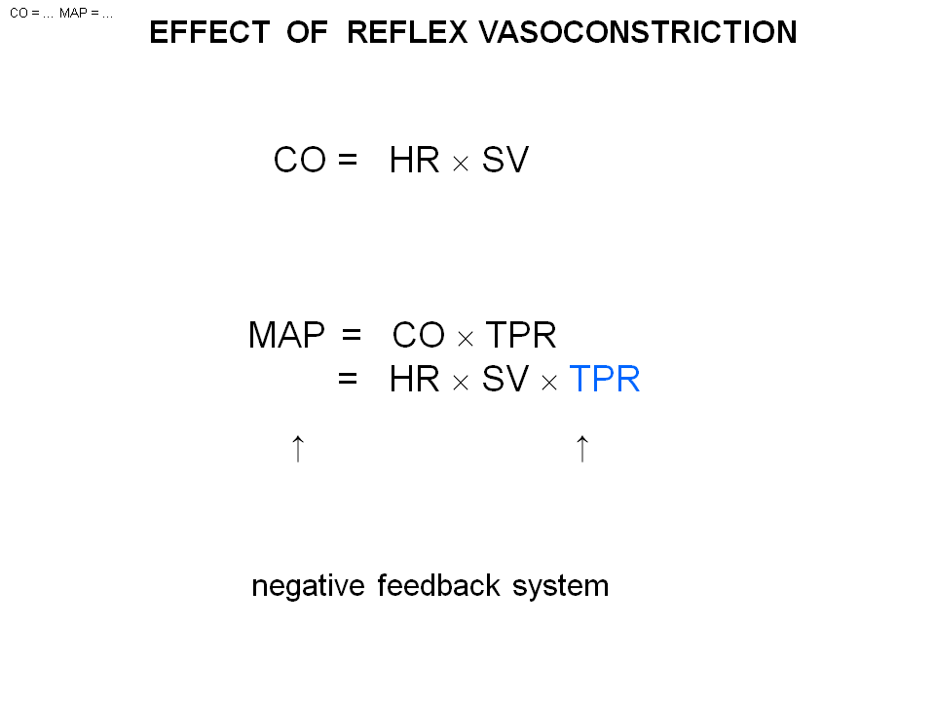
- Constriction of most arterial and arteries in the body (Activation of sympathetic nervous)
- HR, and SV is the Beta reflex
- This constriction is the alpha reflex
- The TPR increase increase the BP

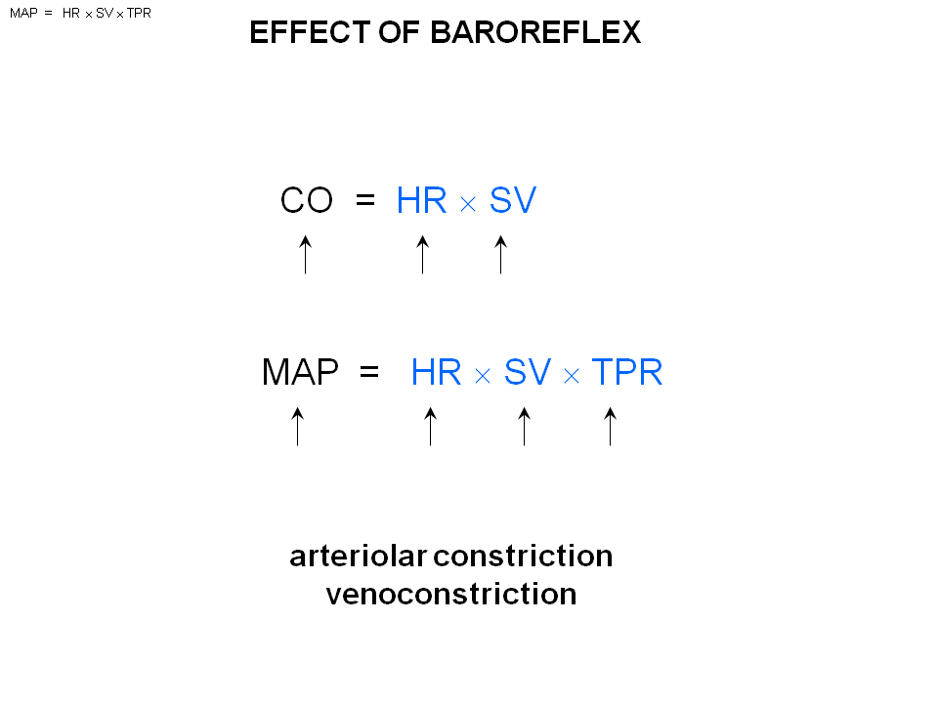
The effect of Baroreceptor is to work on all the component of co,hr, tpr RRESTORE MAP (mean arterial blood pressure)
- The alpha receptor is found in most arterial in the body (artery , arterials , vein, and venues)
- TPR is control by Arterials and small arteries
- But the activation of sympathetic nervous system will squeeze on vein, and venues
- But this is equally important to the constriction of arterial. Why?
- The heart rate can only come out, when what comes in. When no blood is coming back to ventricle, even increase the contractility there is no effect.
- Have to make sure there is more Blood comes back to ventricle
- The vein/venue constriction will increase the pressure in the vein. If have some fluid and squeeze down on it. The pressure in the fluid will goes up. What is the pressure drive the blood to the vein? It is vein pressure!!! So the pressure in venous will increase and drive more blood back to atrium. The atrium will fill more. The pressure in right atrium will goes up. (The pressure difference of atrium drive the blood to ventricle, during the 2/3 of cardiac cycle) more blood back to ventricle , end diastolic volume goes up the heart stretch more the hear constrict more forcefully stroke volume increase. CO goes up , Map goes up
- So the baroreceptor 4 things: 1) increase heart rate 2) increase stroke volume 3) increase TPR 4) increase venue constriction
- Also the parasympathetic nervous system. What the baroreceptor will do is to decrease para tone, which increase the heart rate even further

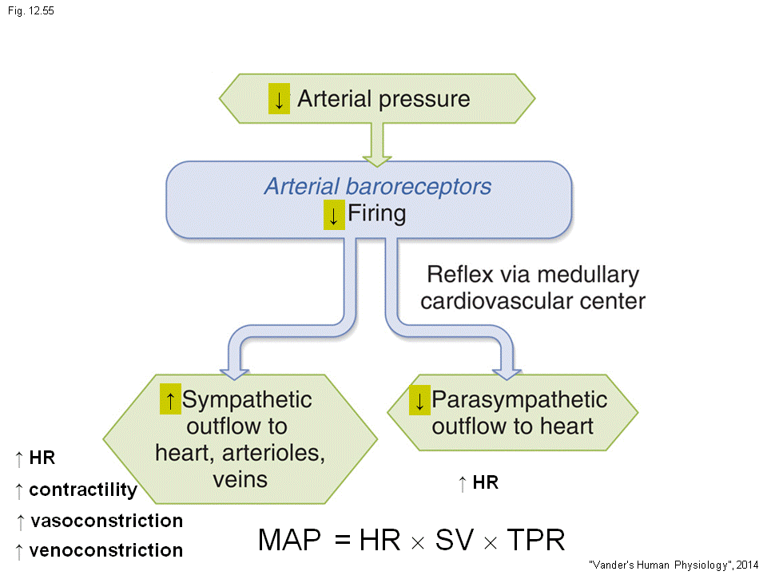

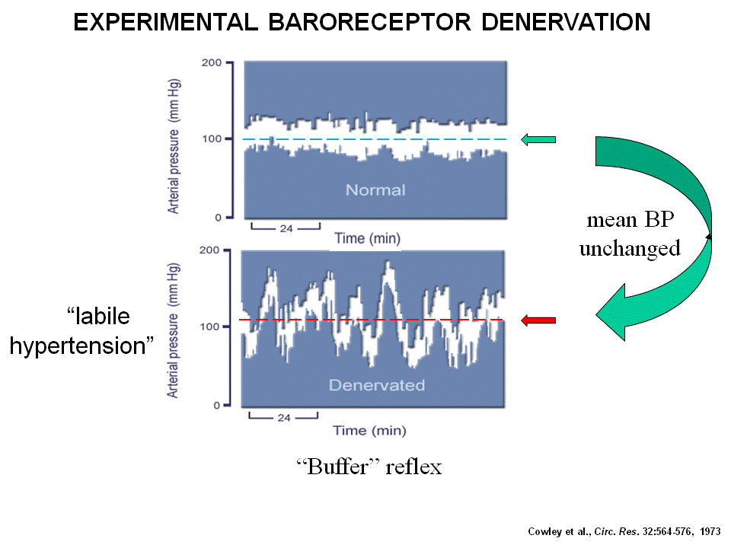
This is the recording of arterial blood pressure in a dog
- Take the dog, cut the baroreceptor. ( So the baroreceptor is firing but can’t get into the brain )
- Innervated baroreceptor is no longer working.
- A few days after ( the second diagram, the same also happen in ppl with neck surgery or radiation surgery –lost of baroreceptor)
- Systolic arterial is extremely high level (almost 200 mmHG)
- Diastolic is extremely low (50 mmHg)
- Call labile(something is changing) hypertension
- The blood pressure fluctuate a lot
- The buffer reflex put the baroreceptor back to the animal: able to go back to normal (The range is buffered, the BP is keep down in a very narrow range)
- Mean arterial blood pressure is no change with or without the baroreceptor
- The purpose of baroreceptor is not to keep the BP in a constant level, but to prevent the wild fluctuation
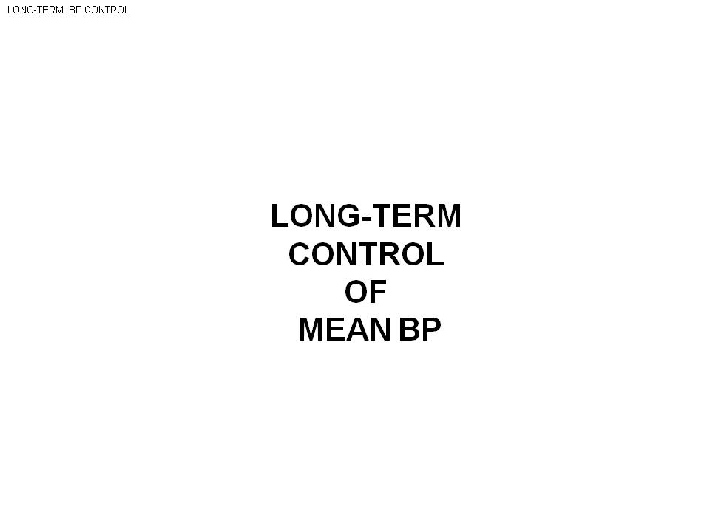
The second reflex control the long term , this is your kidney

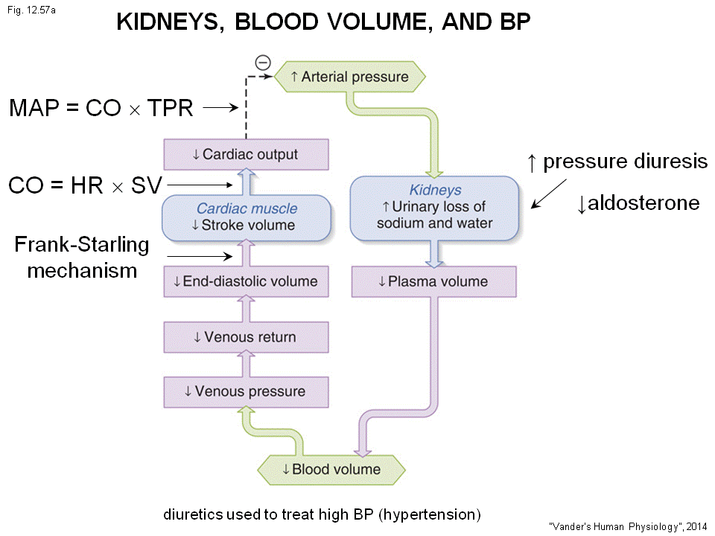
the Bp is control by Kidney over months and years because the kidney controls the volume of plasma in the blood
- It involve steps
- Blood pressure increase
- Kidney find out, extract more water from the blood and send it out to urine
- You pee more as the Bp goes up
- This is called the pressure diuresis ( pressure up, loss H2O)
- Make less aldosterone( hormone to reabsorb H2O and Na+)
- Direct effect of H2o and aldosterone ( plasma volume down
- Blood volume down (Blood : 60% plasma , 40%RBC)
- If the blood volume down, most of the blood store in vein and venue the pressure in vein/venue drop
- Return down
- EDV down
- Less stretch in the wall, the stroke volume goes down
- CO down
- Map down balance the high Bp
Essential (unknown cause) hypertension: can be in kidney 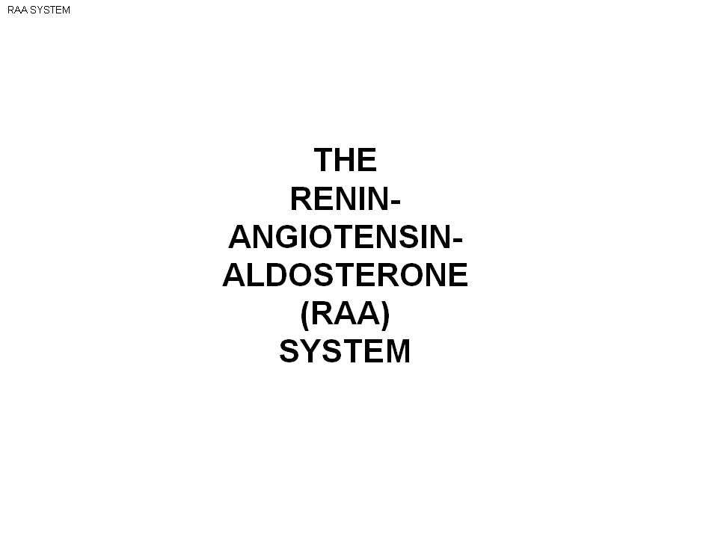

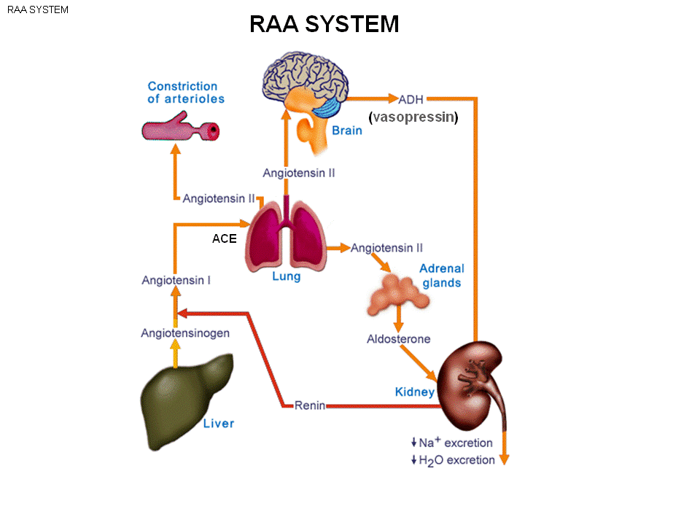
RAA have lots of effect all over the body
- Cardiovascular : 3 effect to control blood pressure
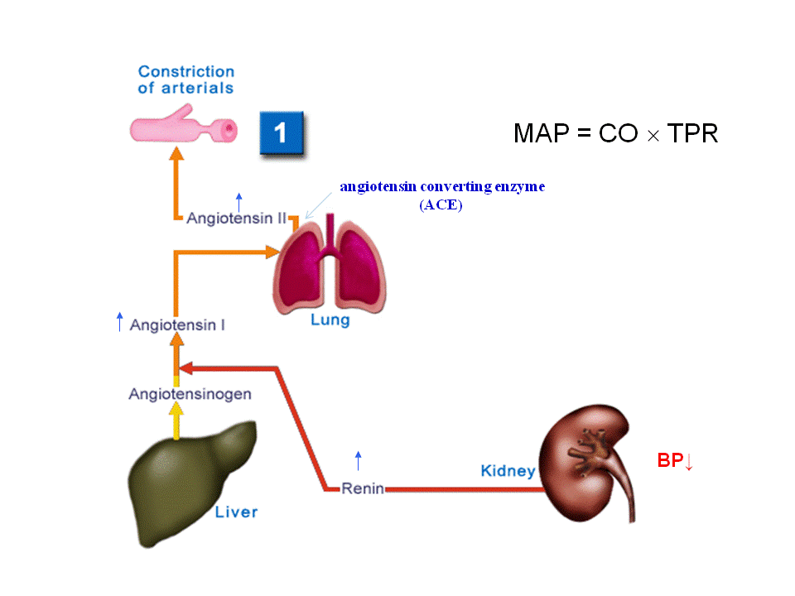

If Bp drop, the blood pressure in renal artery will drop.
- The cells in the wall of arterials of kidney that make renin
- When arterial pressure drop, arterial dump more renin in the circulation
- Renin concentration goes up ( It’s a enzyme)
- Chop off Angiotensinogen to Angiotensin1 (This circulate in the blood than go to the lungs)
- The lungs make enzyme call ACE (angiotensin converting enzyme) chop off the amino acid of Angiotensin1 to Angiotensin 2. (This is the activate form )
- This angiotensin goes everywhere in the body and bind arteries’ receptor in the body and cause them to constrict
- Map = CO* TPR
- TPR goes up, the BP goes up
- This is the 1st of 3 effect of angiotensin 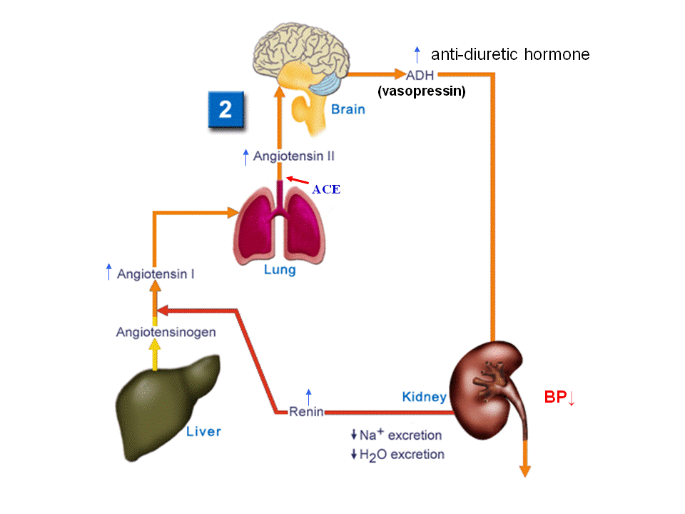
- The angiotensin also goes up to the brain and bind to angiotensin2 receptor (like in the previous slide)
- Effect of ADH
- Renin angiotensin1 angiotensin2 cause increase of ADH (anti-diuretic hormone)
- ADH: work on kidney (anti- diuretic: loss less H20, and the whole chain of 8 steps we saw before, bring the blood pressure back up)
- ADH, another name vasopressin (constrict arterials) => increase BP
- This is the 2nd action
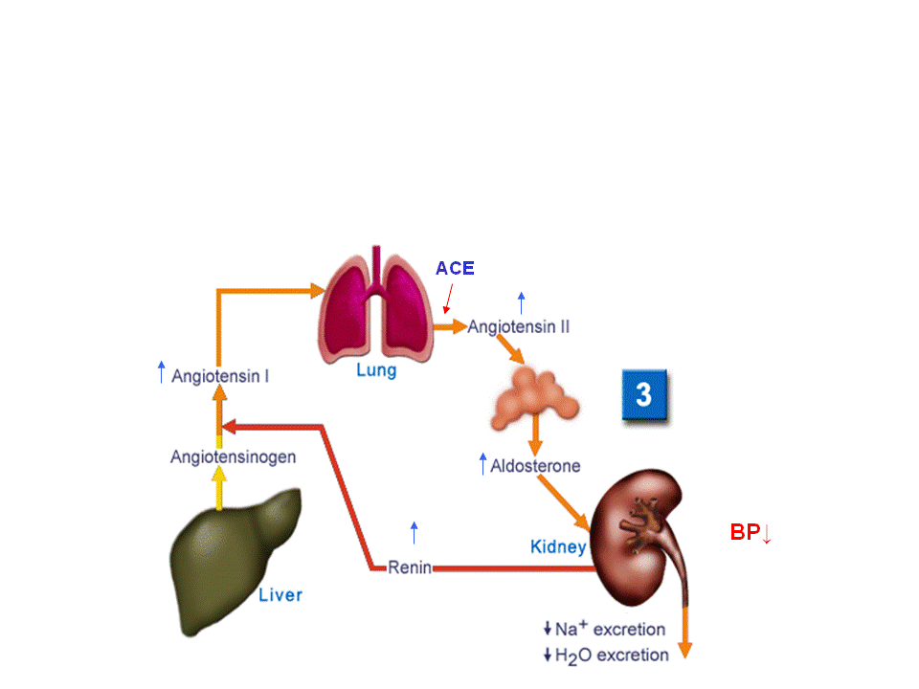
- The angiotensin2 act on adrenal gland
- adrenal gland produce aldosterone
- aldosterone make the kidney keep Na+, H2O
- so the blood volume goes up, Bp goes up
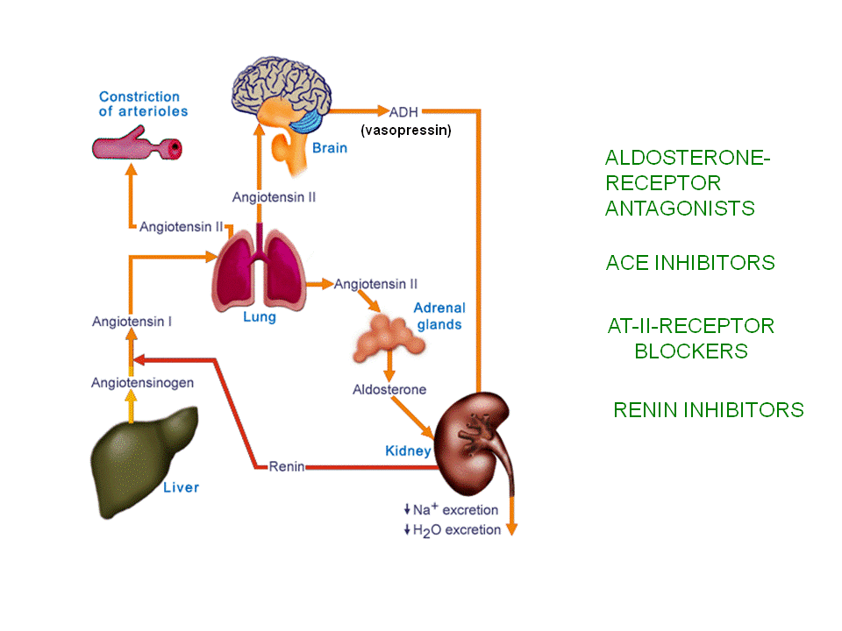
The RAA system is the prime site for drug therapy for ppl with high blood pressure
- aldosterone receptor antagonist occupy the receptor but not activate, the BP will receptor (aldosteron can’t bind, don’t retain H20, blood volume falls, blood pressure falls)
- ACE inhibitors Ace is the enzyme that convert angiotensin1 to angiotensin2. If inhibited, can’t make angiotensin2. BP drops
- AT 2 receptor blocker occupy the receptor but not activate, the BP will receptor (angiotensin2 can’t bind , unable to constrict vessel)
- Renin inhibitor make less of angiotensin1, and angiotensin2, bp falls
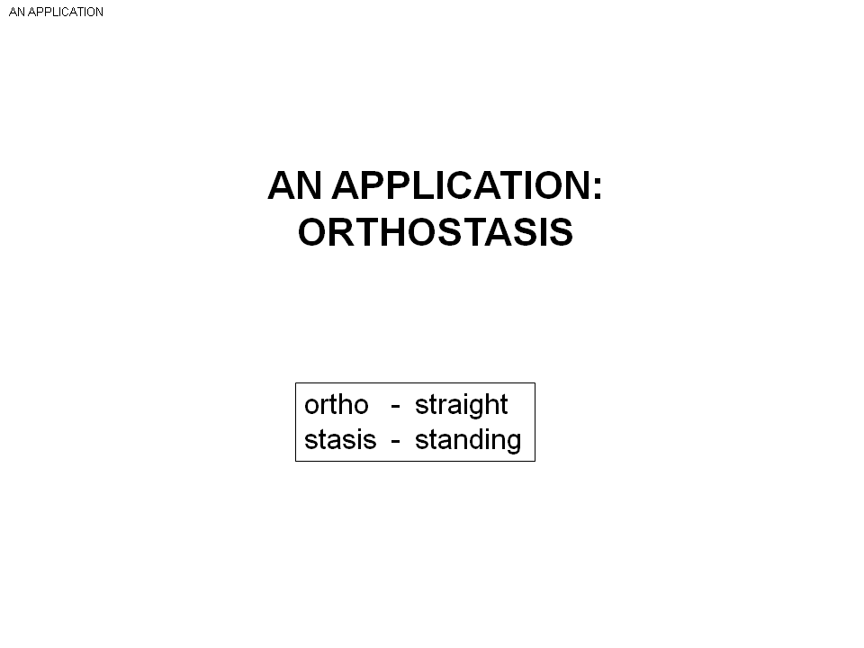
2 applications:
- Ortho (strait) stasis (standing) : a state been upright
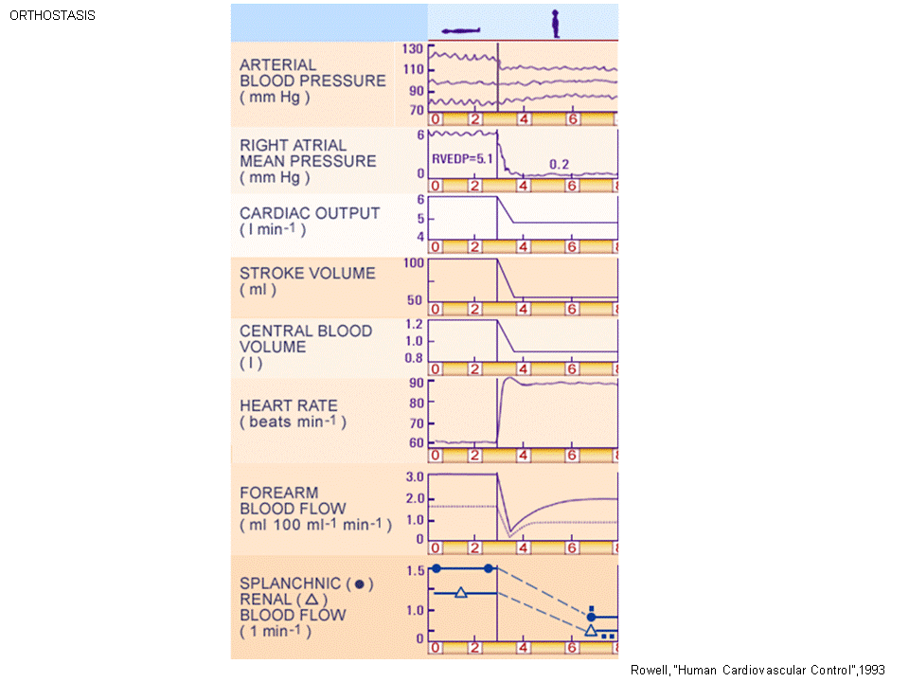
The left is the laying position, right is the standing position (orthostatic position)
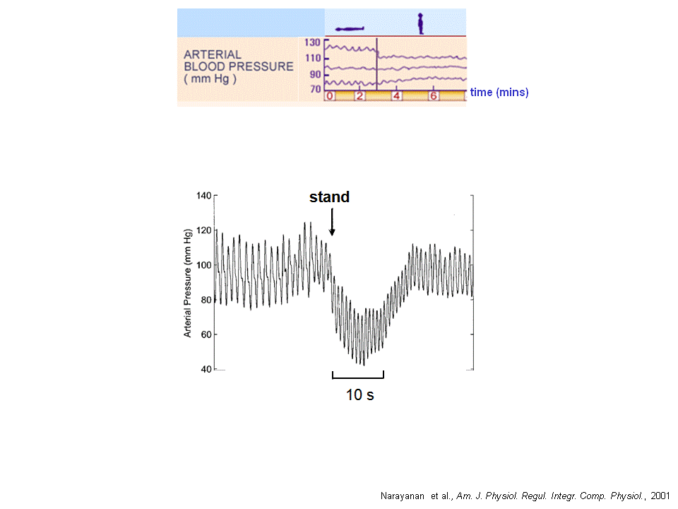
When stand up, the mean arterial blood pressure doesn’t change
- If the baroreceptor reflex is not working, and stand up : faint
- But this is the normal ppl
- Map doesn’t change
- Small change in systolic bp, and small increase in diastolic blood pressure
- This is a long time (2 min scale ---so something is missing
- If we look more closely:
- The continuous recording of Bp in the diagram below, within 10s (10 beats of the heart ) the blood pressure has drop
- The Map goes from 100 mmHg 50 mmHg 100 mmHg. ( this is the baroreceptor reflex)
- If don’t have the baroreceptor reflex, this will fall and stay down. You faint, and mbp stays at 40mm Hg. (You faint when 60mmHg)
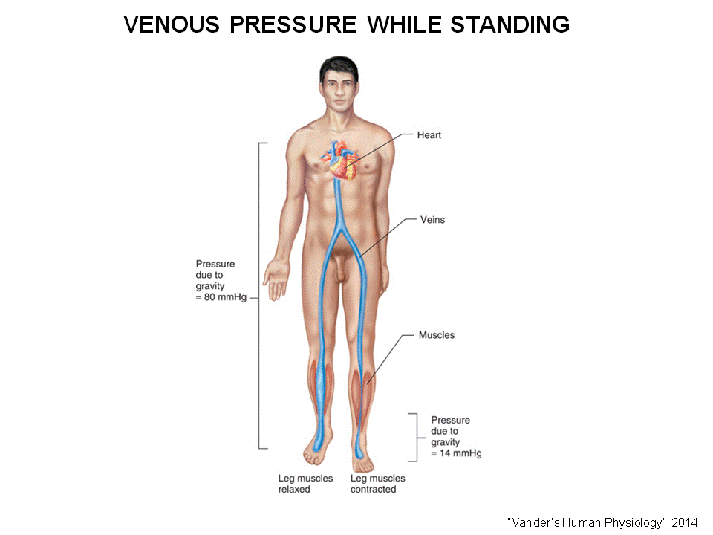
Hydrostatic pressure, if stand up. The blood comes to all the way down to your feet in an average height man (170 cm) , the pressure of the bottom of the foot ( 80mmHg.)
- Arterial blood pressure is 100mmHg if lye flat
- If stand up the pressure in both artery and the vein goes up 80 mmHg in foot.
- The veins are more stretchy, (as you go down the body, the pressure increase)
- The pressure in vein: 80 mmHg (hydrostatic) + 10mmHg (usual venous pressure) = 90 mmHg in the foot (normally the pressure if the foot vein is only 10mmHg , now increase by 10X)
- The stretchy vein will stretch out
- So the moment when you stand up, you immediately loss several 100 ml of blood from your chest ( next diagram)
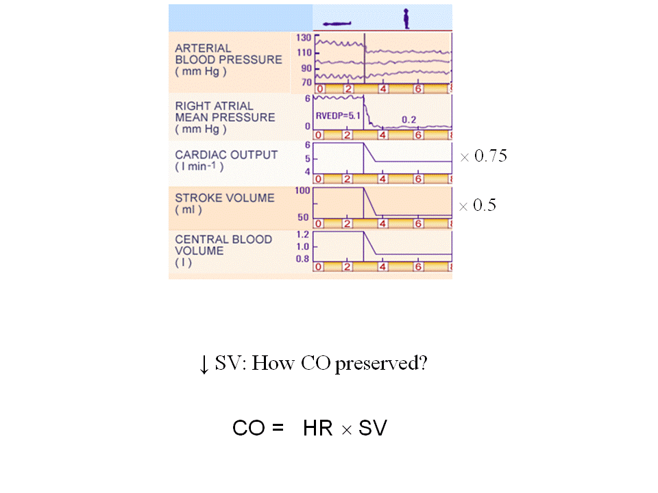
The total volume in the chest is call the central blood volume. (the blood in lung, heart...)
Here you lost from 1.2 L to 0.9L ( 300 ml of blood lost ) this happens you stand up
- The blood is not able to go back to the heart (less blood goes back to the heart)
- What happen to the blood in right atrium!!
- Drops, because the right atrium is not as full
- This person: right atrium pressure drop from 6mmHg to 0 mmHg
- If the right atrium is not filling, what happen to the right and left ventricle.
- Not filling, how do they pump out?
- Pump out less
- So this person : the stroke volume drop from 100 to 50 ml when stand up
- The decrease of stroke volume affects both cardiac output and the blood pressure
- stroke volume drop 50 percent but cardiac output drop 75 percent. What happen?
- Heart rate must have increase (next diagram)
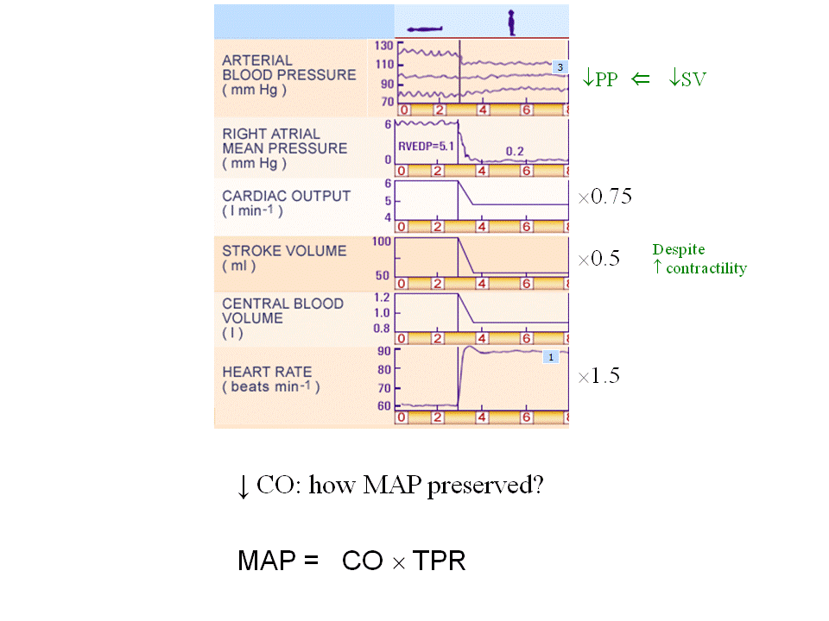
This person heart rate went from 60 up to 90. ( by a factor of 50%)
Map?
- Map don’t change
- But the cardiac output drop 0.75
- The TPR must change (next diagram)
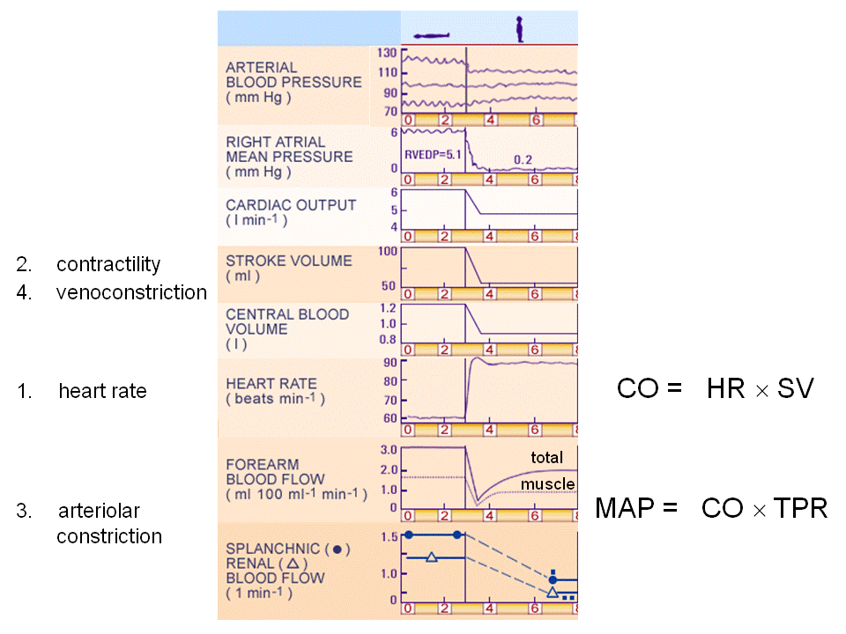
The blood flow to forearm, splanchnic circulation, kidney
- All the blood flow has drop, even Map doesn’t change
- This organ happens arterial constriction
- This is all due to baroreceptor reflex
- The increase in HR (baroreceptor detect the drop in pressure at very start)
- baroreceptor increase contractility in vessel (if this didn’t happen the CO will fall to less than 50 %) to put the TPR up
- vessel constriction in the vein, this help to increase the venous pressure to help blood come back to the heart. ( able to pump out blood , keep the CO, TPR high)
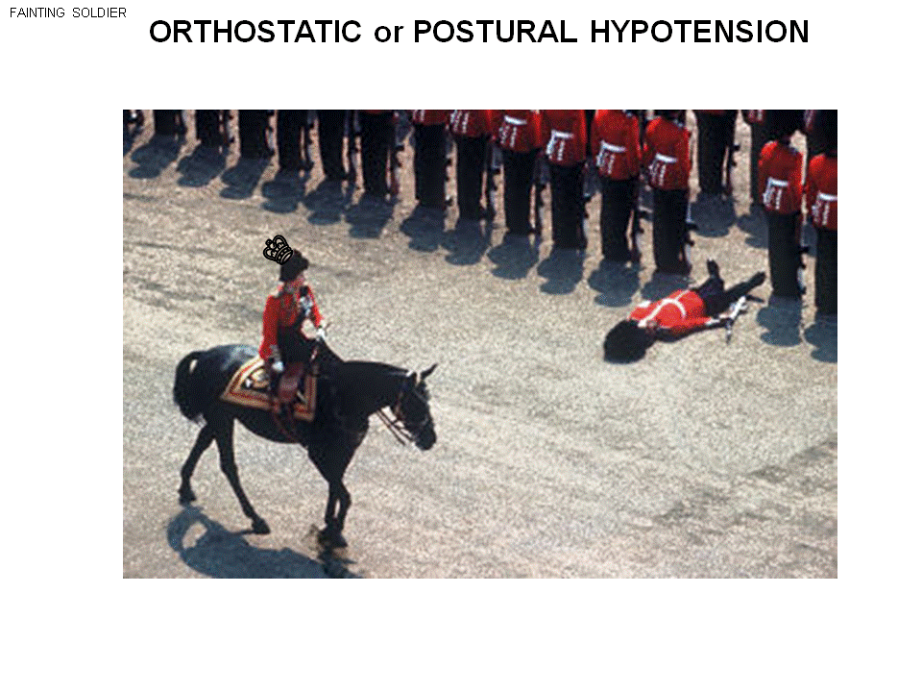
Some ppl faint, this person stand up after 30min

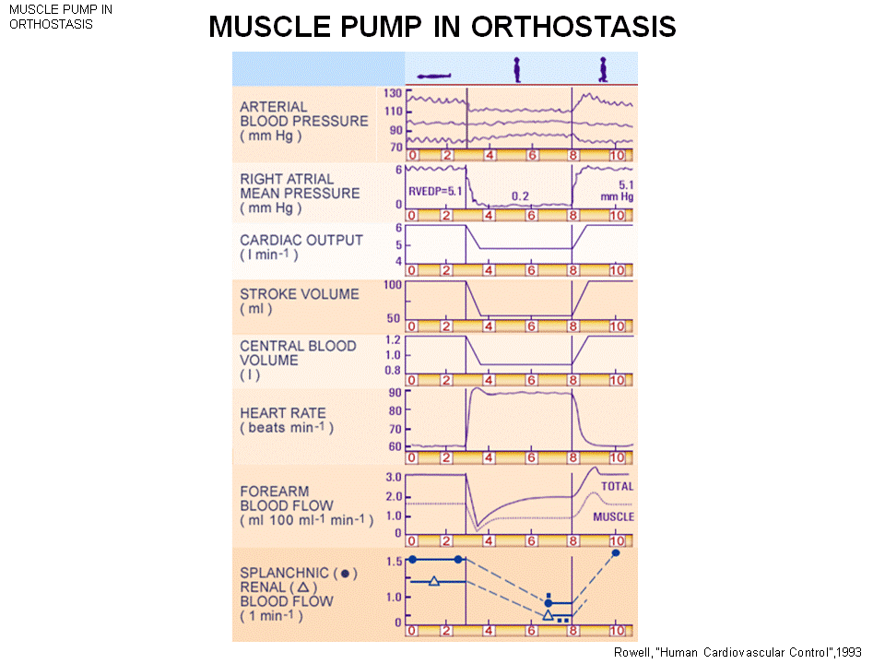

When stand up contract chief muscle unconsciously.
- Stand for a long time but don’t contract the skeletal muscle, all the variable goes back to the first state as you are lying flat (the activation of chief (skeletal) muscle recruit the third heart (pump) of your body – you have 4 cardiovascular pumps= left ,right heart , muscle pump, respiratory pump )
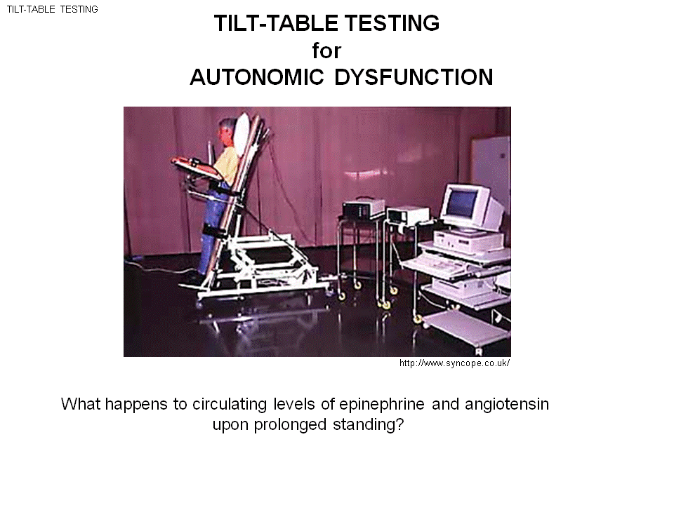
He raises the person up.
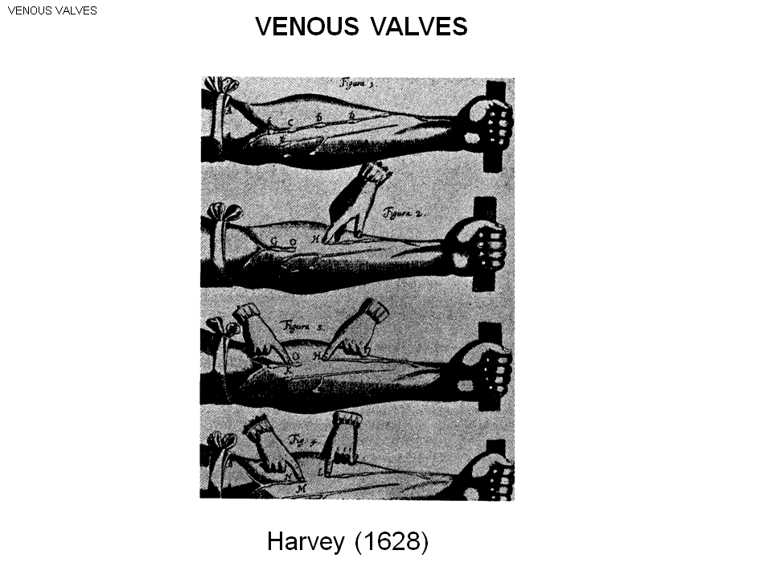
In arms and legs there is venous valves, these are one-way valve allow the blood to flow in only one direction.
- You can feel the valve, this allow the one direction
- Press the valve and use other fingers to sweep the blood out of the object: now the vein is completely empty
- If let go thumb, still empty: because the valve is stop working
- If bring the 4 fingers up. What happen? The flow back
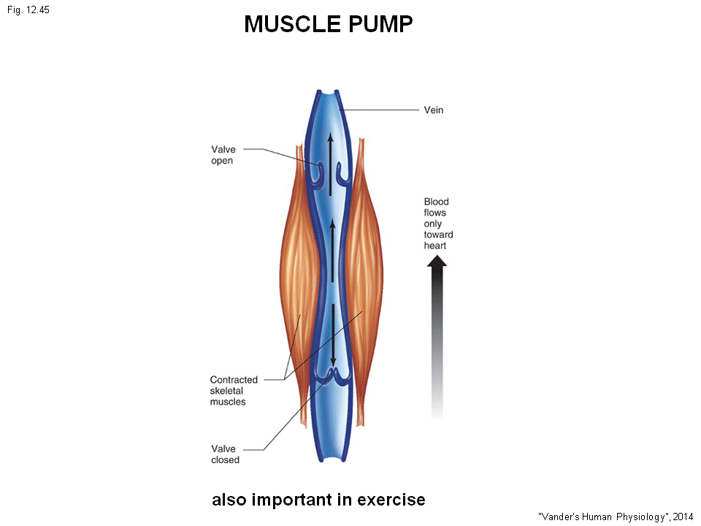
Contract the chief muscle, the skeletal muscle was squeeze down the veins in the leg
- The pressure in vein will goes up ( this is a one way valve, similar to heart increase in one direction will make the valve open or close depend on where)
- This help to increase the venous return to the heart, and increase the return heart fill more starling’s law contract strongly the Stroke volume up, Co up
- This muscle pump is important help exercise, help increase the blood back to the heart
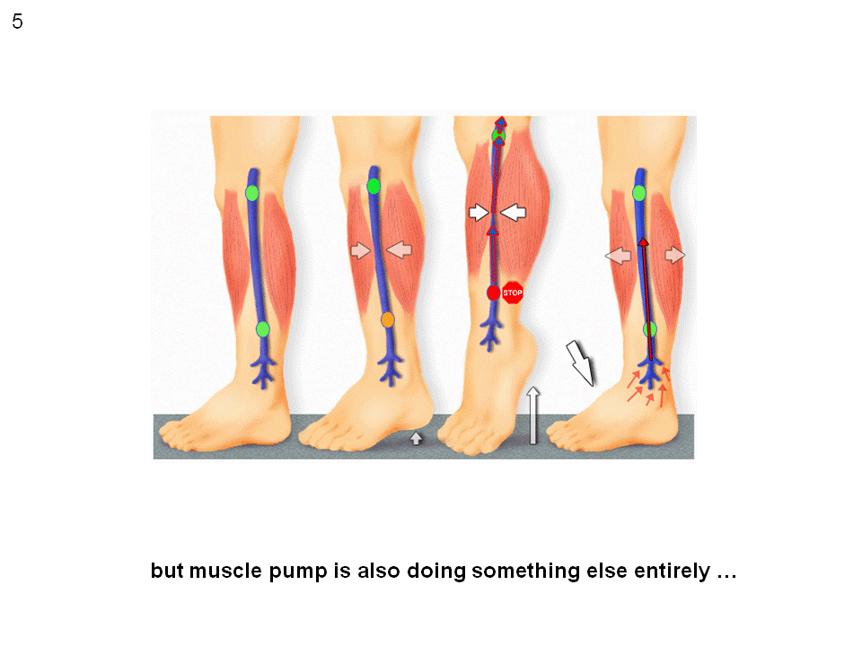
Its also doing something entirely different
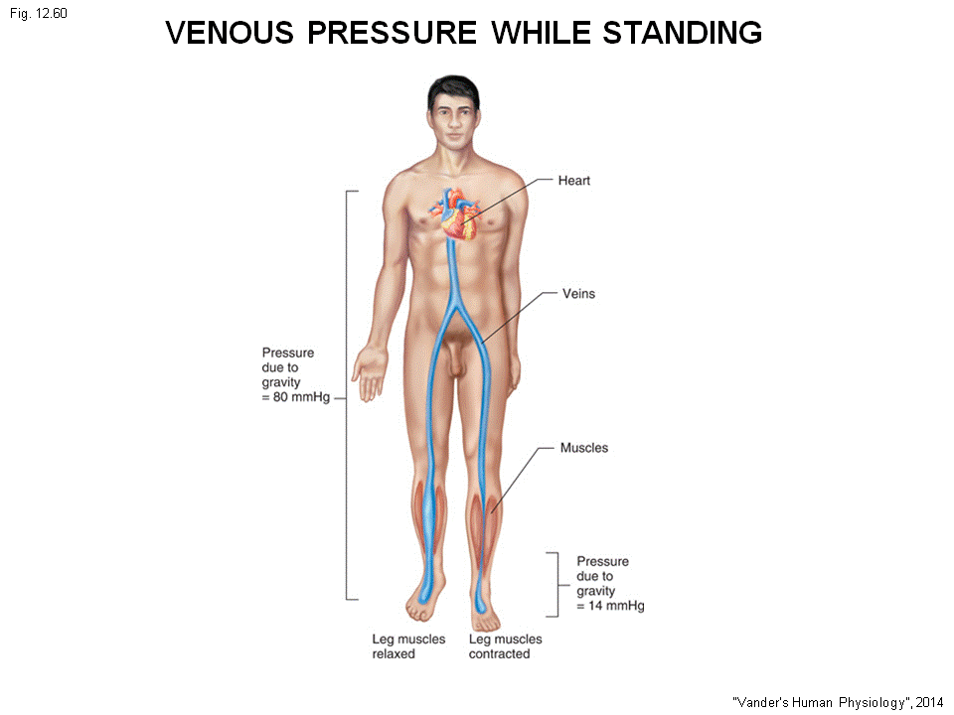
If stand up the huge hydrostatic pressure in the lower leg
- If you stand to long , ankle hearts , the huge hydrostatic pressure in the vessel and the vein
- The hydrostatic pressure in capillary also goes up and push the blood (water) to the interstitial space and cause edma (swelling)
- How does the muscle pump help here?
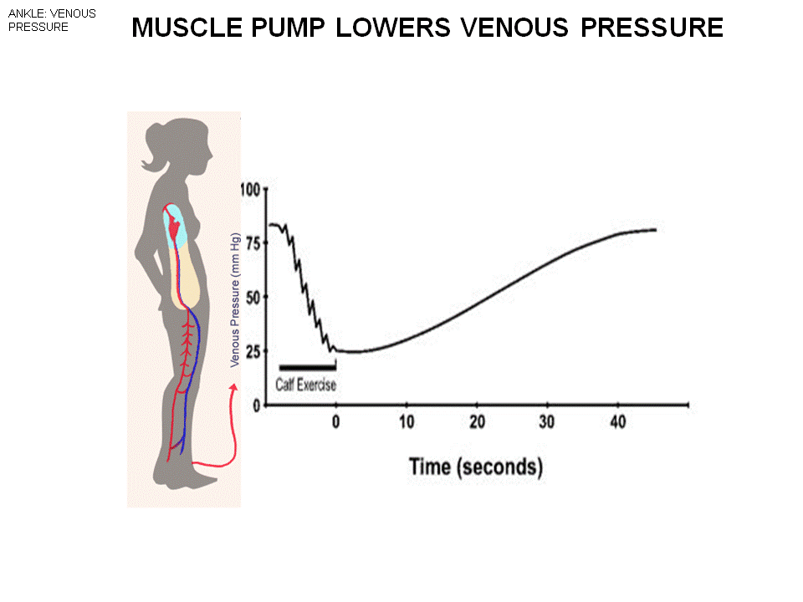
If contract (stand for a long time, and don’t contract chief muscle: you get the full hydrostatic pressure.)
- This person hydrostatic pressure: 80 mmHg
- If contract the muscle: the pressure fall. You see the each falling is due to contract
- Now contract 6~7 times , pump the blood in the vein, pressure drop to extremely low value
- And after sometimes (~few 10 sec) the pressure comes back up
- If your vein is normal, walk around, even at rest spontaneously contract the chief muscle
- This keep the pressure in the vein low, so the pressure in capillaries is also low
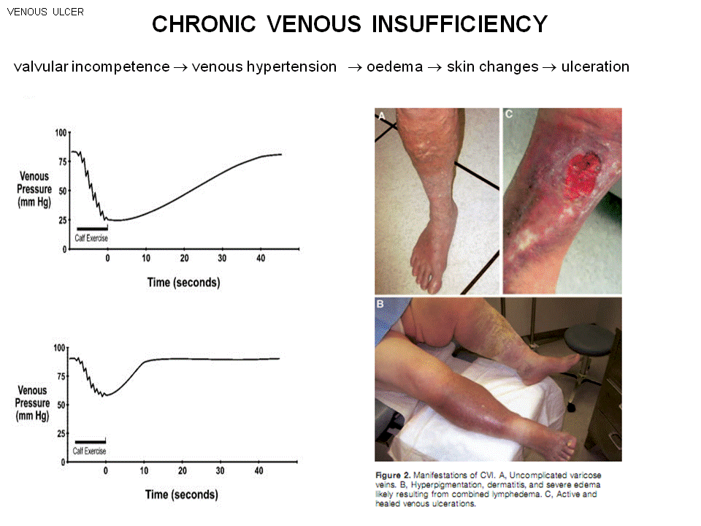
As you get old, get Chronic venous insufficiency
- The valve bo longer work as one way valve
- As contract the skeleton muscle
- The blood goes both ways , the valve leaks
- The pressure in the vein builds up , also up in capillaries
- The right up is the normal person
- But with Chronic venous insufficiency, the pressure don’t go that low and comes back immediately
- Get edema skin change ulceration
- See the skin color change, especially in diabetic person
- All because of the unworking one way valve
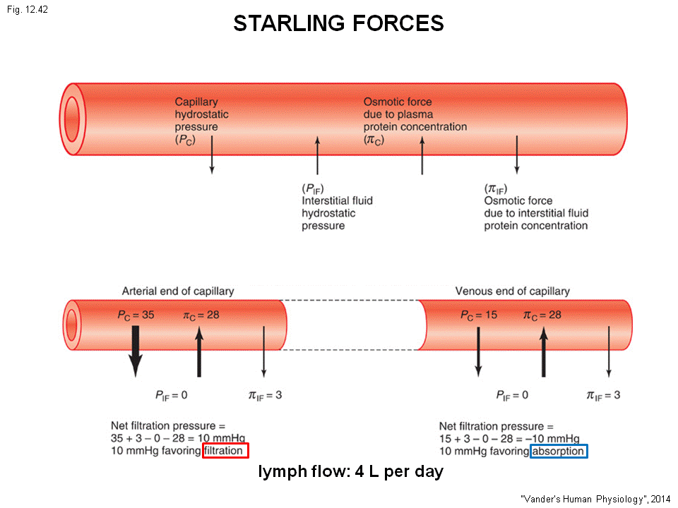
If the pressure in the capillaries goes up
- The starling forces increase, loos fluid
- Under normal circumstances at the arterial end:
- The pressure is 35 , the osmotic pressure at 28 (suck the fluid in)
- The pressure in interstitial space is 0 .
- Net pressure of 10 mmHg that force the water out of the vessel
- As move down the vessel, the pressure falls
- The net force is from outside to inside (-10mmHg), suck the fluid back in
- But you don’t reabsorb that much fluid as you filtrate
- So you loose 4L of plasma (the normal blood volume is 5L, and the plasma is 60% = you have 3 L of plasma) Can you afford 4l loss???? No!!!
- The excess filtration has to come back!! ---the lymphatic !!
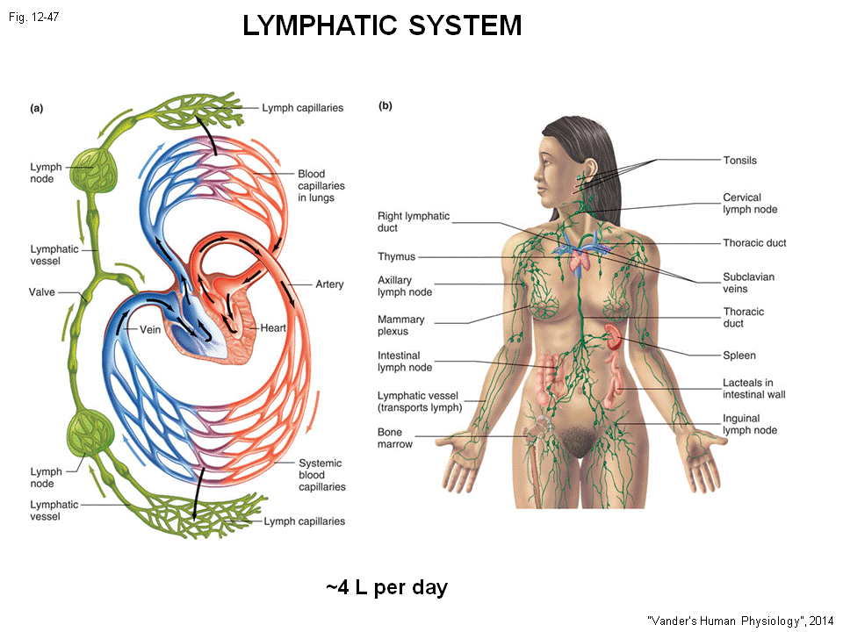
The lymphatic system
- When lose fluid , it enters this vessels and get returns to cardiovascular system
- The lymphatic system form nodes (if infection, the nodes grow)

